ESTIMATION OF BUSINESS EXPENSES

1.INTRODUCTION:

1.1 OVERVIEW:

This involves estimating all the expenses required to start and operate the business, such as equipment, rent, inventory, and marketing.

By calculating these costs upfront, business owners can better plan their budget and avoid unexpected expenses.

Businesses evaluate the expenses involved in the manufacturing of a product or service.

Estimation helps set a profit margin and sales price. In project management, this method gives investors an idea of the approximate expenses incurred in the completion of the project.

1.2 PURPOSE:

Estimates are important because they allow business to set expectations for their customers.

They also help business determine whether or not project is feasible and how much profit they can expect to make.

Estimating also allows businesses to plan for unforeseen expenses and keep track of spending.

Estimates are documents that provide approximate costs for a project. FreshBooks has an estimates feature that help you bulid an estimate quickly and easily.

2.PROBLEM DEFINITION & DESIGN THINKING:

2.1 EMPATHY MAP:

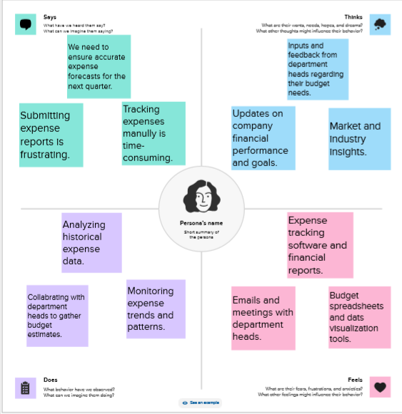

2.2 IDEATION & BRAINSTROMING MAP:

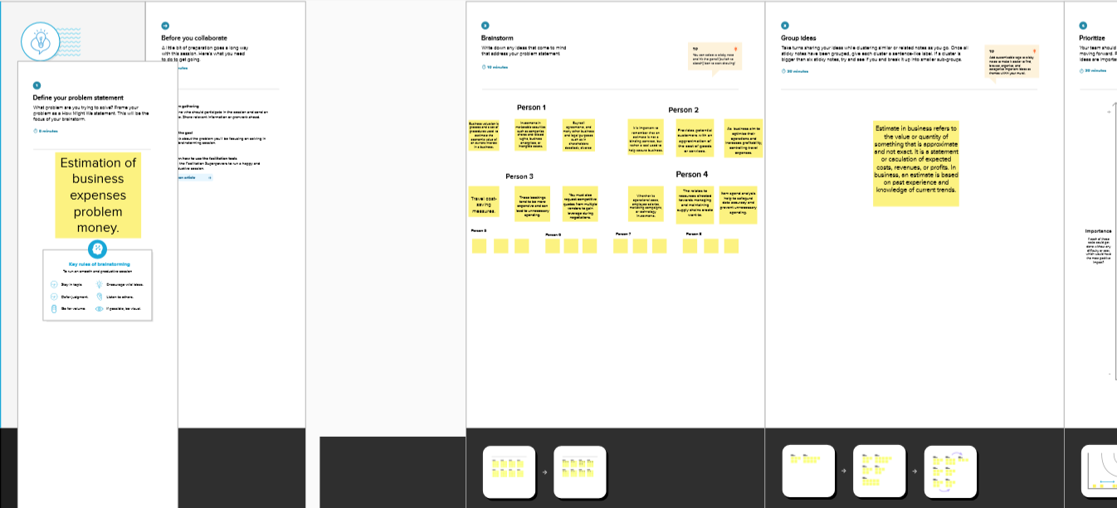

3.RESULT:

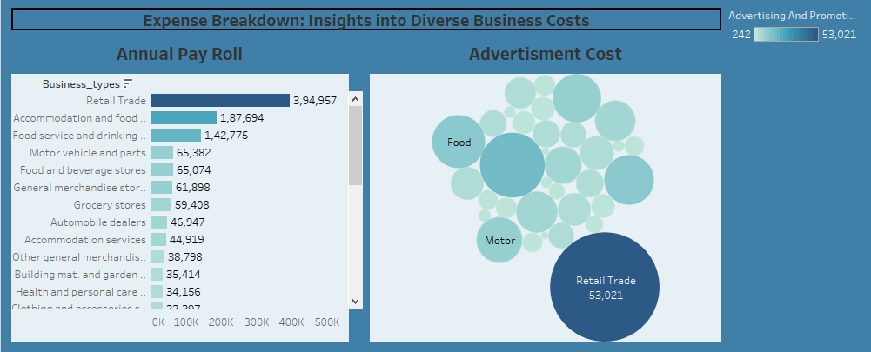

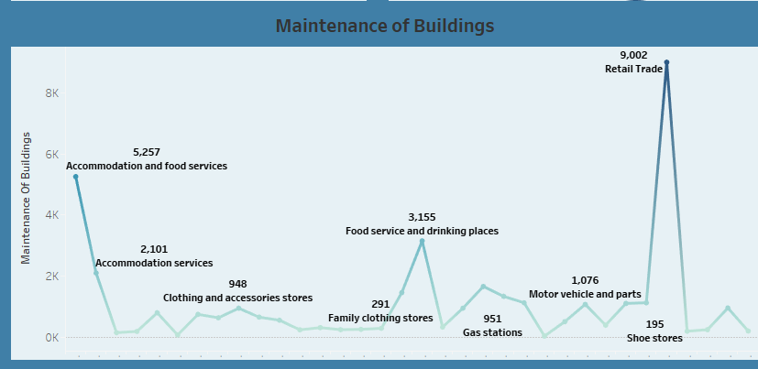

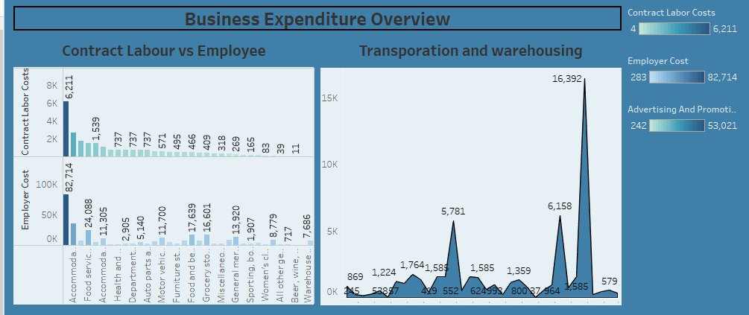

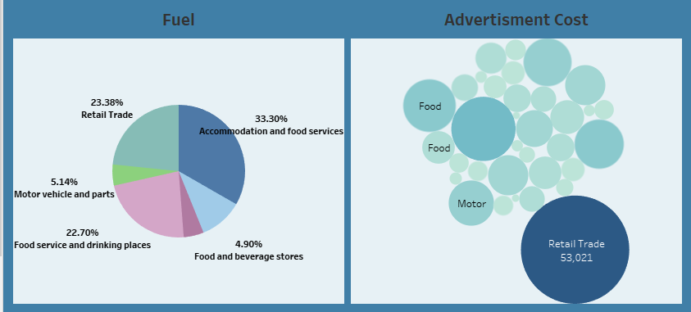

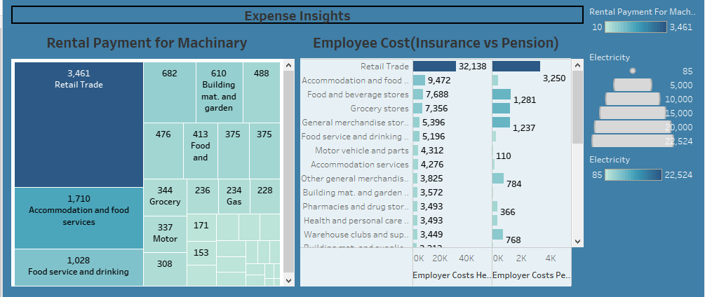

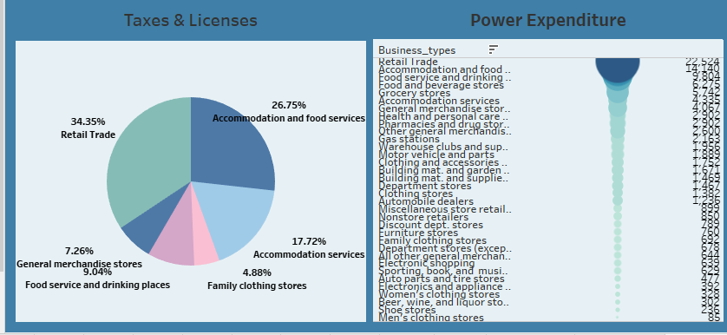

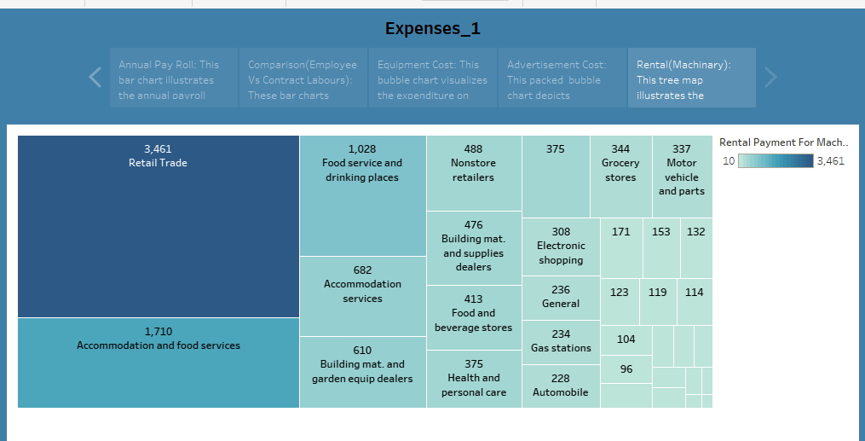

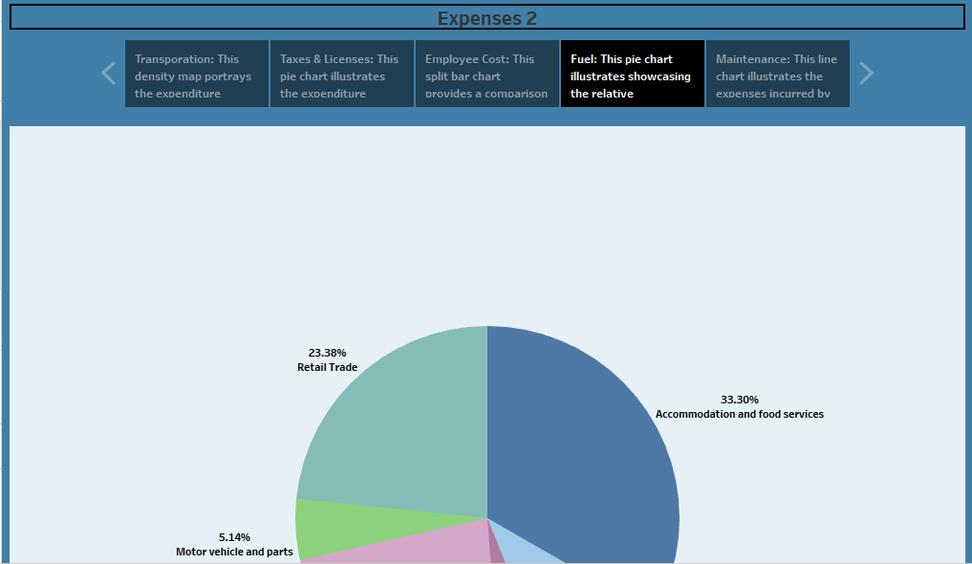

4.ADVANTAGES & DISADVANTAGES:

ADVANTAGES:

* Helps in setting prices
* Identifies unnecessary costs involved
* Enhances productivity
* Helps the management make effective decisions

DISADVANTAGES:

* Records past data
* Costs keep changing every interval
* Experties required
* Expensive maintenance

5.APPLICATION:

The cost principle is an accounting concept that requires companies to record costs at historical value.

This avoids the use of market or fair values that can change in a short time period and create confusion on financial statements.

Application of the cost principle include accuracy, reliability, and consistency. The end result typically leads to a conservative approach for reporting financial figures.

Both internal and external stakeholders rely on this information in order to make decisions and assess a company’s financial viability.

In most cases, all activities that involve the use of inventory, accounts receivable, or accounts payable require the application of this principle.

The use of historical cost is not without controversy, however, as companies may actually underreport the value of their goods.

6.CONCLUSION:

In conclusion, cost estimation is an important component of project management that ensure projects are finished on schedule and within budget.

Science inaccurate cost estimates can have serious financial conseqences for businesses, accurate cost estimating is crucial for all stakeholders engaged in a project.

It is crucial to consider a variety of elements that affect cost build-up, such as the complexity of the project, scale and scope, time, proper project planning, familiarity with essential procedures, and the client’s financial status, in order to increase the accuracy of cost estimation.

7.FUTURE SCOPE:

An initial cost estimate can determine whether an organization greenlights a project. If the project moves forward, the estimate can be a factor in defining the project’s scope.

Once the project is in motion, the cost estimate is used to manage all of its affiliated costs in order to keep the project on budget.

Cost estimation in project management is the process of forecasting the financial and other resources needed to complete a project within a defined scope.

Cost estimation accounts for each element required for the project-from materials to labor-and calculates a total amount that determines a project’s budget.

8.APPENDIX:

https:/www.smartcapitalmind.com